F &D Project

***SUBMITTED BY :-SHRUTI***

***GROUP :- 17 (2010992097) CSE***

***EMAIL:-shruti2097.be20@chitkara.edu.in***

***CONTACT:- 7403933000***

***SUBMITTED TO:-MR. LAVISH ARORA***

**PROJECT 1:- ELECTROSHO**

-(commercial based website)  
 -(made using HTML,CSS, javaScript)

**PROJECT 2:-NEO- *BAGS THAT SPEAKS FOR YOU*** -(handbags website)

-(made using HTML,CSS, javaScript

& additional framework BootStrap)

**PROJECT 3:- Portfolio**

-(Resume-based)

-(made using HTML,CSS &BootStrap)

* LET’S MOVE TO PROJECT 1

ELECTROSHOW

**DETAILS**– ELECTRONIC WEBSITE THAT NEVER COMPROMISES WITH IT’S QUALITY.

###### HOME PAGE

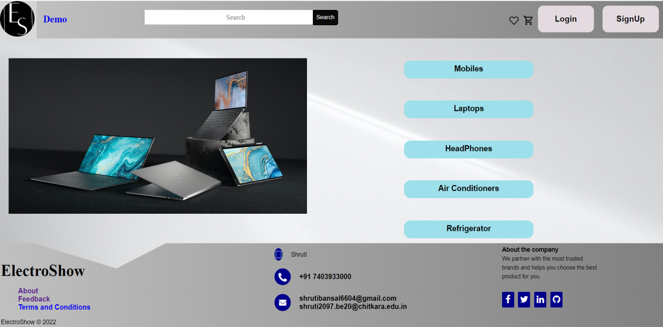

* First thing you see us our Logo of our website ES(initials of ElectroShow)
* The page starts with Navigation bar(which includes buttons- demo page, login, sign up, search bar).
* Icons in navigation bar represents Add to favorites and Cart.
* Buttons of different category to acess there **category page** are made using css property and transition property is used on them. On hovering width decreases to 100px.
* To make slideshow **@keyframes**is used to specify the animation code i.e. by writing down the direction in which images has to move either left or right.
* Footer was divided into 3 divs i.e. footer-left, footer-center, footer-right to align the items used.
* Clip path CSS property is used to give the design as it creates a clipping region that sets what part of an element should be shown.

###### ABOUT US

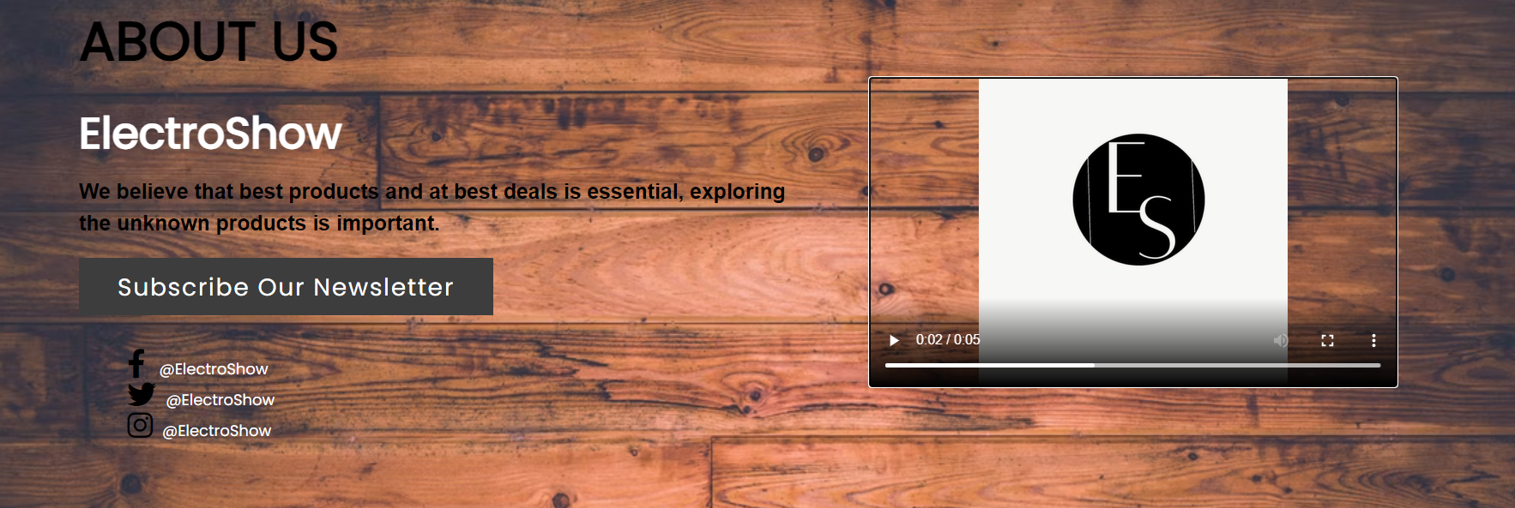

* Title itself tells what the page is all about. Good domain name will **create awareness and attract customers**. It establishes your business as tech-savvy and forward-thinking.
* Video tag is used to display the transition of logo.
* Font awesome icons are used like facebook, twitter and instagram and they are linked to our social pages named with our domain name.
* User can subscribe to our newsletter to receive daily updates on our website.

###### SIGN UP

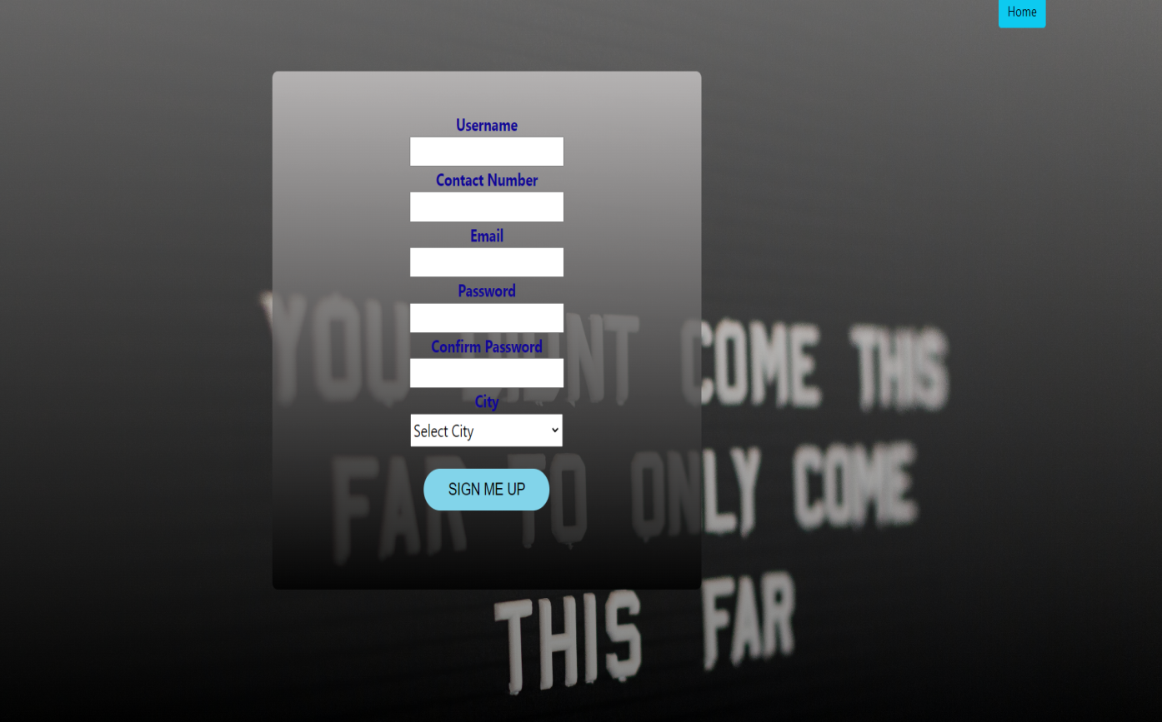

* Sign up page is made for new users. They enter their personal information (which is completely save with us) to access the complete features of the website.
* Using bootstrap property home button is given on top-right side.
* In background-image linear gradient is used to give the blur effect.
* **Syntax**: background: Linear-Gradient(direction, color-stop1, color-stop2*, ...*);
* Javascript is used for validation of the user name, password and confirm password, contact length is checked upto maximum limit.

###### LOGIN

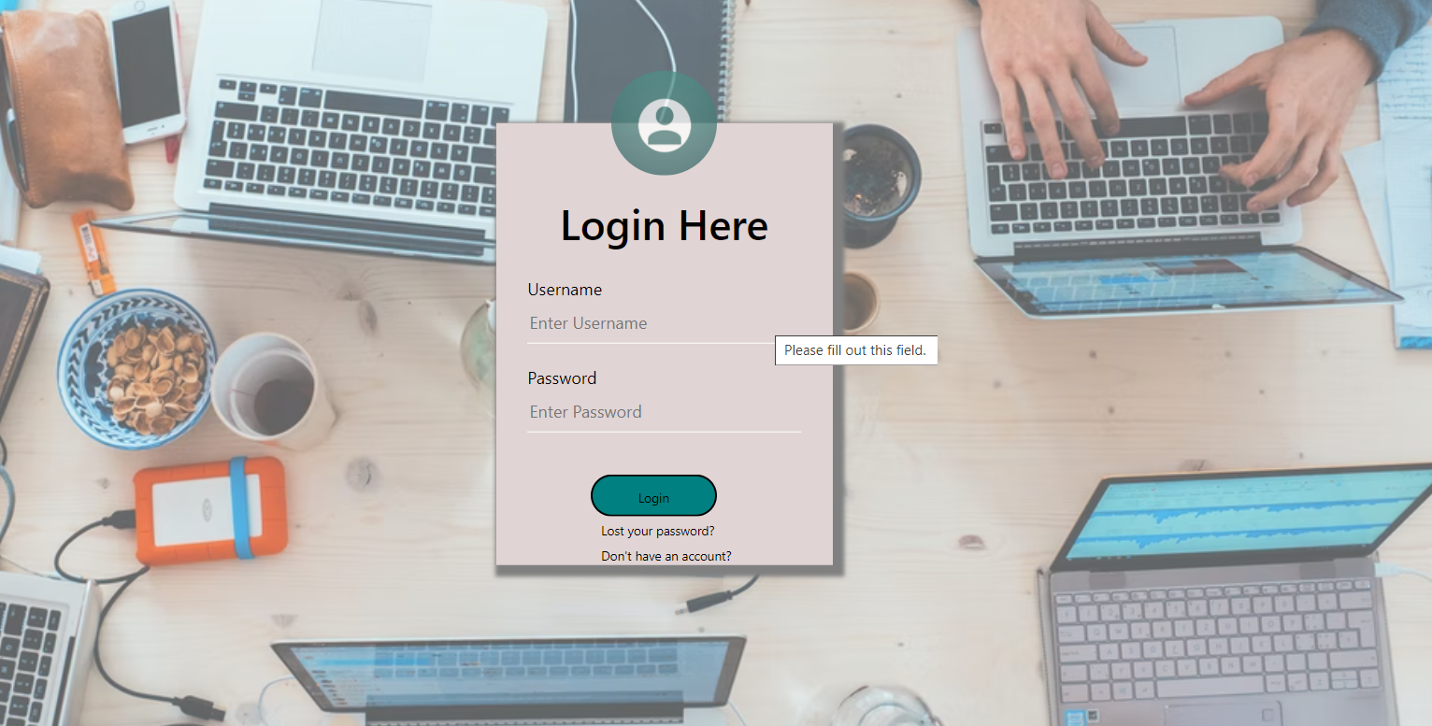

* Background image is added and further it is blurred using opaque property.
* transform: translate(value,value) is used to specify the position of the login box in the center.
* Box-shadow css property is used to given shadow on sides of login box.
* On hovering over the Login button text color and button color changes to red and yellow.
* If the user doesn’t have the account they can register using the “Don’t have an account” option.

###### DEMO

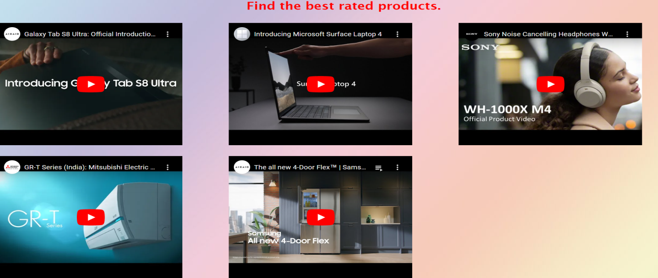

* Videos are embedded to help user to find the latest and best rated products.
* On hovering over the “Find the best rated products” color changes from white to red. This also acts as a button. On clicking background image changes to blue colored image.

###### **FEEDBACK FORM**

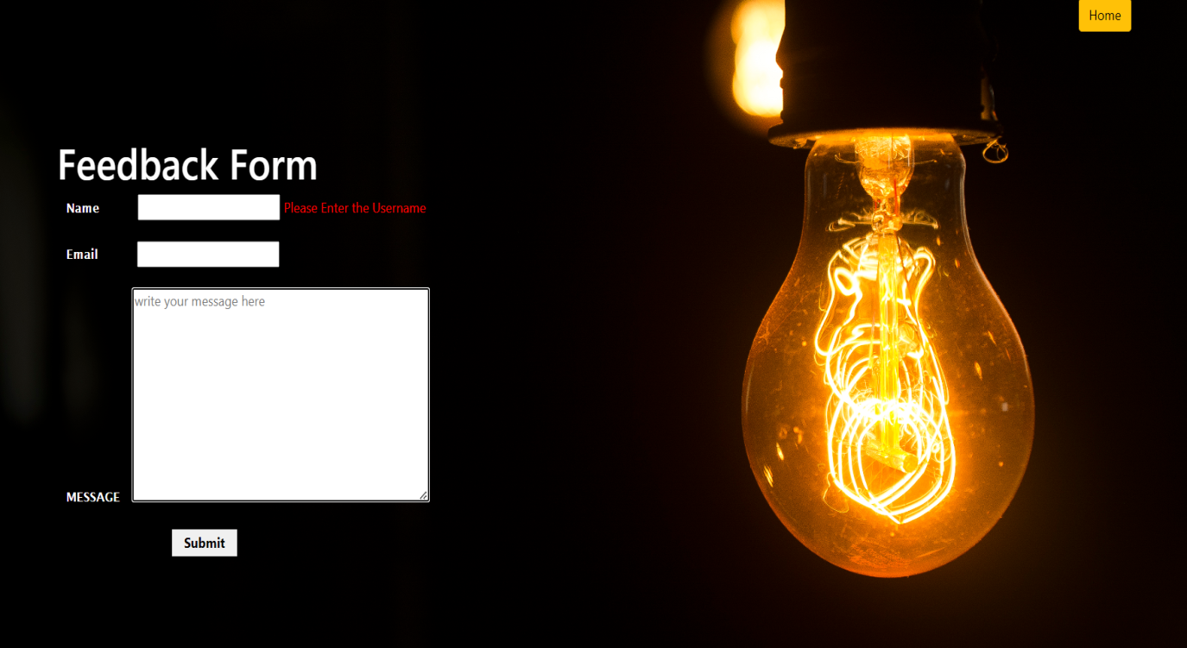

* Feedback form is provided to collect opinions on services provided and if they faces any issue .
* Home button is set to the rightmost side using bootstrap.
* Background image is set using background properties like background-image,position,size,repeat.
* javaScript is used for validation as shown in the picture. Name and email is necessary for the submission of the form.
* Maximum limit is also set using javaScript.
* LET’S MOVE TO PROJECT 2

NEO-BAGS THAT SPEAKS FOR YOU

**DETAILS** – A BAG CAN MAKE OR BREAK YOUR ENTIRE FIT.

###### **HOME**

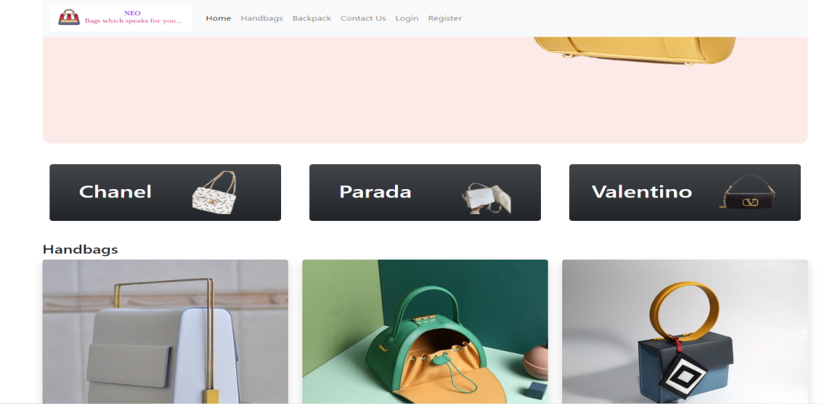

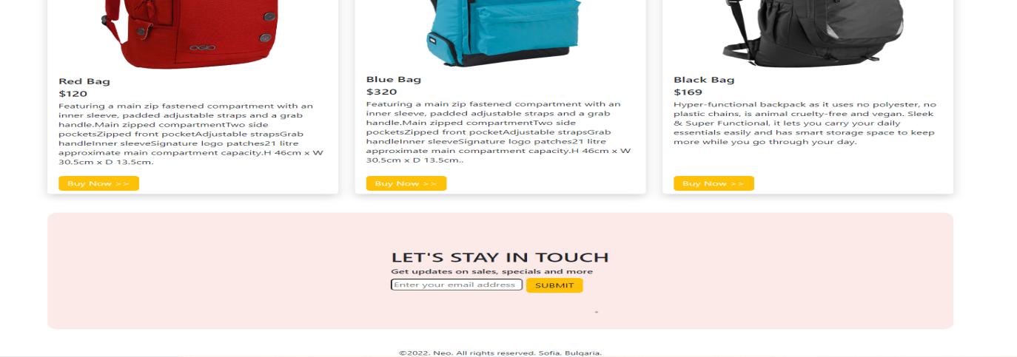

* NEO –title of the website means something new you will get i,e. new collection of handbags, wallets, backpacks and more.
* BootStrap provides the responsive website.
* On clicking the logo of the website you can visit About us page which is discussed later.
* Inbuilt properties are used like container-fluid which covers the full width of the browser window with no margins on the left or right side.
* collapse navbar-collapse refers to the menu that is in the mobile view with the navbar.
* carousel slide panda-carousel is used in slideshow for cycling through the elements.
* User can subscribe to our newsletter to receive daily updates on our website by providing their email id whose access is given in footer.

###### **ABOUT**

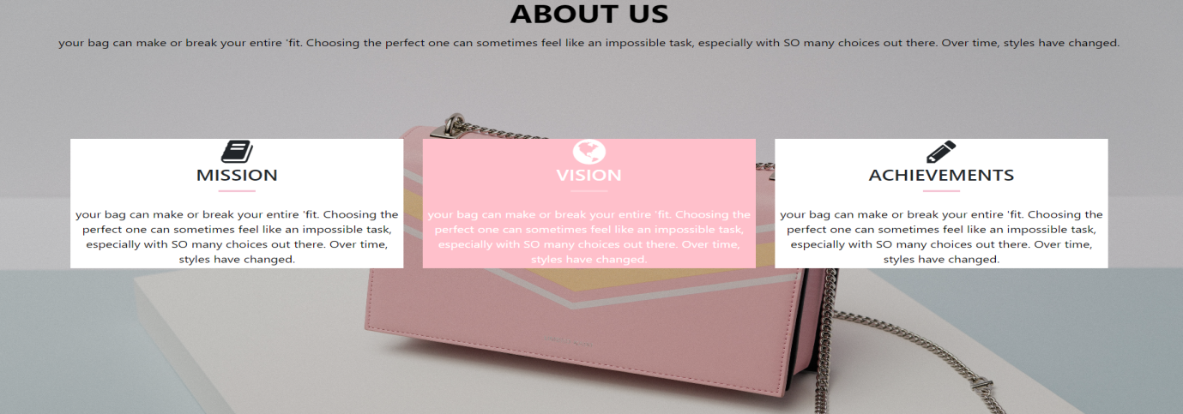

* Title itself tells what the page is all about. Good domain name will **create awareness and attract customers**. It establishes your business as tech-savvy and forward-thinking.
* Font awesome is used for the icons like mission, vision and achievements.
* Container class provides a responsive fixed width container.
* On hovering over the icons they start rotating made using bootstrap and css.

###### **SIGNUP**

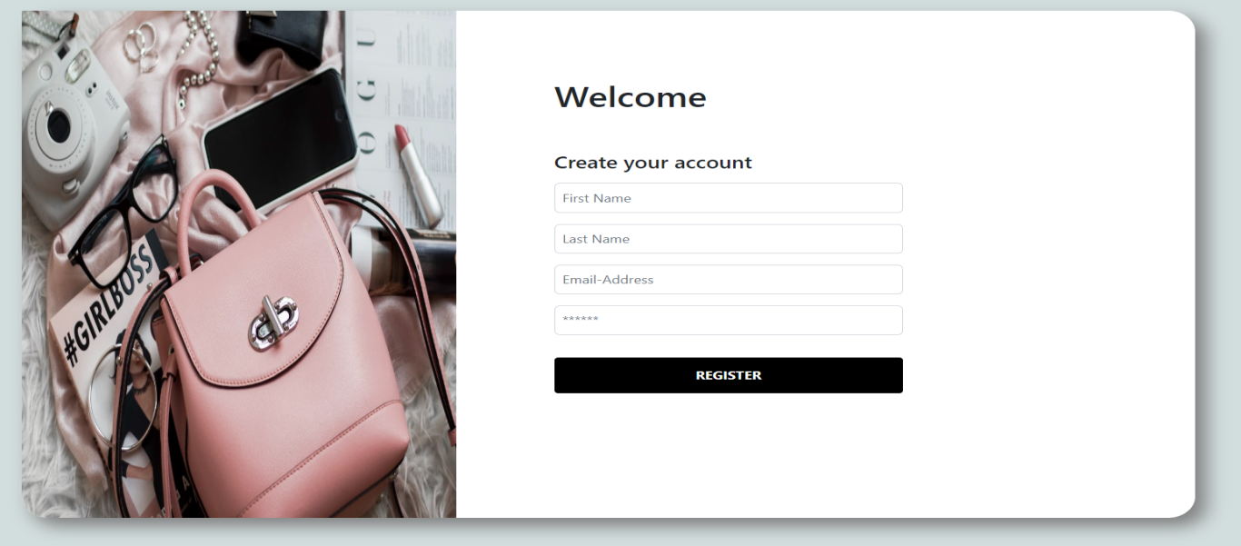

* Sign up page is made for new users. They enter their personal information (which is completely save with us) to access the complete features of the website.
* Using BootStrap inbuilt classes like form, container, col, row responsive page is made.
* Two different divs were made . One for side pic and other for user’s data.

###### **LOGIN**

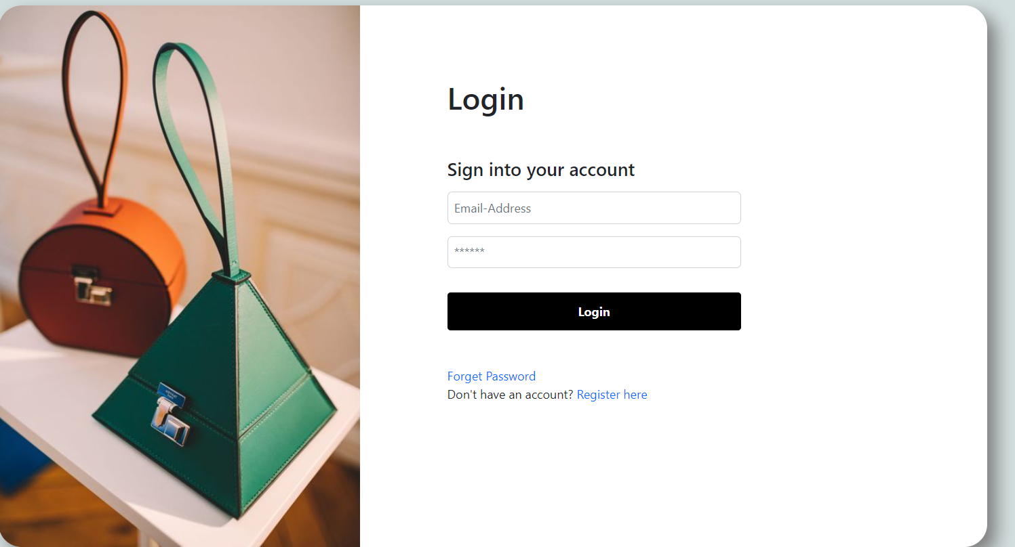

* Using BootStrap inbuilt classes like form, container, col, row responsive page is made.
* Two different divs were made . One for side pic and other for user’s data.
* If the user doesn’t have the account they can register using the “Don’t have an account” option.

###### **PRODUCT PAGE**

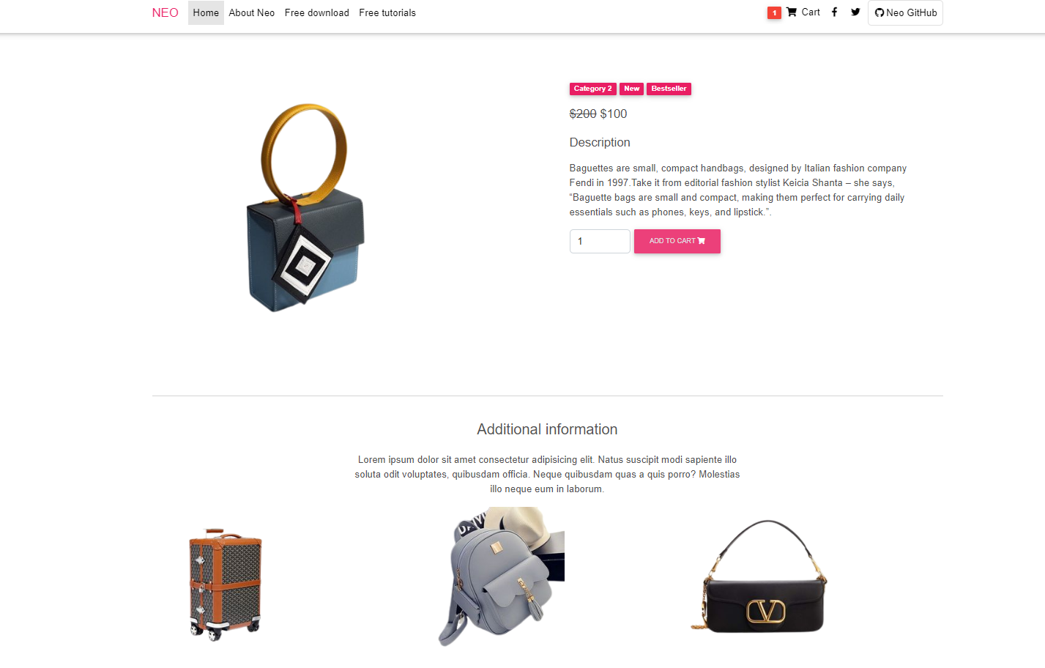

* When user want to buy specific product they can click on add to cart and as many as items they want.
* Description of product is useful so that user can make the right decision.
* Navigation bar is fixed using navclass(navbar fixed-top navbar-expand-lgnavbar-light white scrolling-navbar) i.e. on scrolling nav bar doesn’t disappears.

###### **BUY NOW**

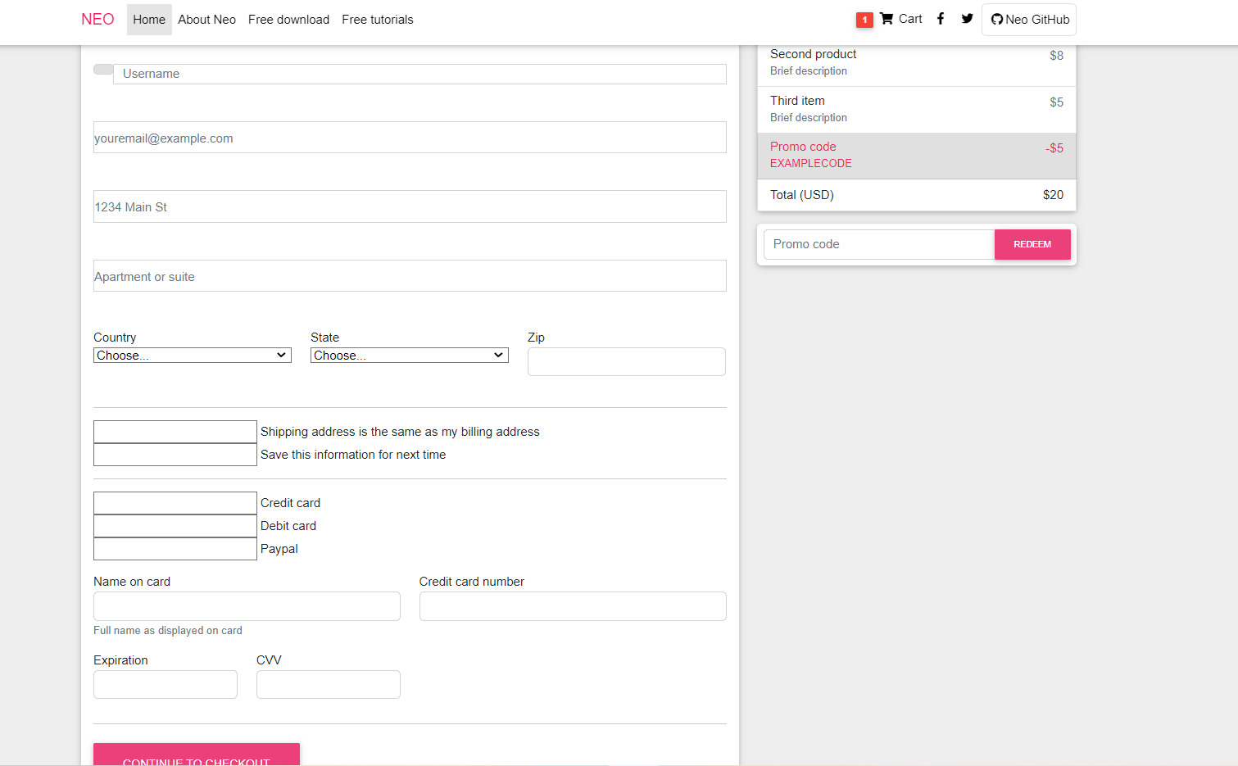

* User can fill this checkout form by providing their name, email address, phone number, address for the right delivery of the product and receive the best product for their use.
* User has to fill the card details for online payment.
* Font awesome icons are used like facebook, twitter and instagram and they are linked to our social pages named with our domain name.
* LET’S MOVE TO PROJECT 3

PORTFOLIO

**DETAILS** – HIGHLIGHTS BEST WORK,SKILLS& ACHIEVEMENTS.

###### **ABOUT**

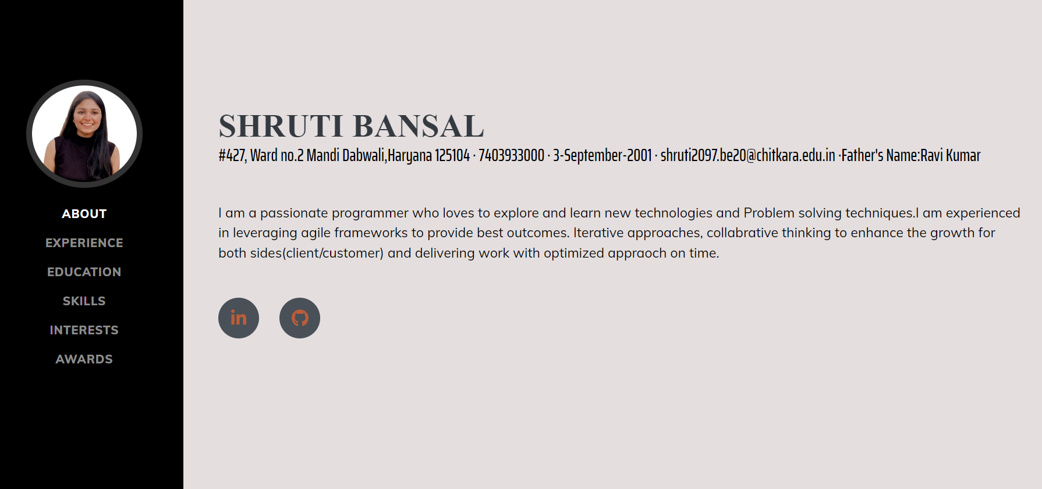

* Portfolio highlights and showcases the brief of one’s best work, experiences, skills and achievements.
* This portfolio is made using HTML, CSS, BOOTSTRAP and JAVASCRIPT.
* It is divided into two divs i.e. navigation bar and information.
* Navigation bar contains all the fields required for the portfolio.
* Inbuilt classes for navigation bar like navbar-brand js-scroll-trigger tells on scrolling which link is active on the viewport.
* About page tells my personal details like address, date of birth, email id, contact number and father’s name.
* It also contains summary about the who you are and what you do.
* Here I have also linked my linkedIn and github account so that recruiter can visit and see my work uploaded there.

###### **EXPERIENCE**

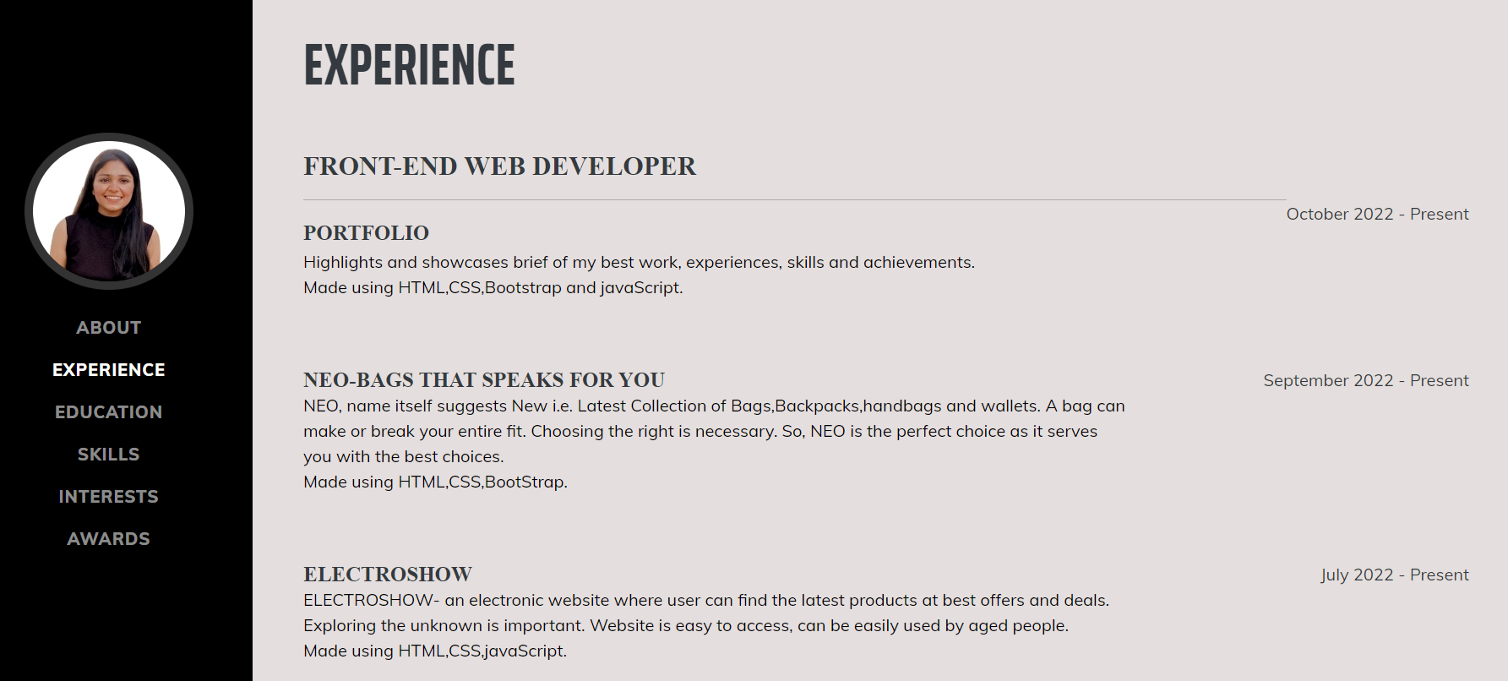

* This page elaborates about the experience I got while working on various projects.
* First is this portfolio- where I learned writing short and brief about our skills, interests and achievements.
* Second is NEO, which deals with bags serves its customers with best choices.
* Third is ELECTROSHOW which deals with electronic products at best offers.
* Class flex-column and justify-content-between is used to divide course name and year into two columns.
* Class flex-shrink-0 aligns the year and date in one row.

###### **EDUCATION**

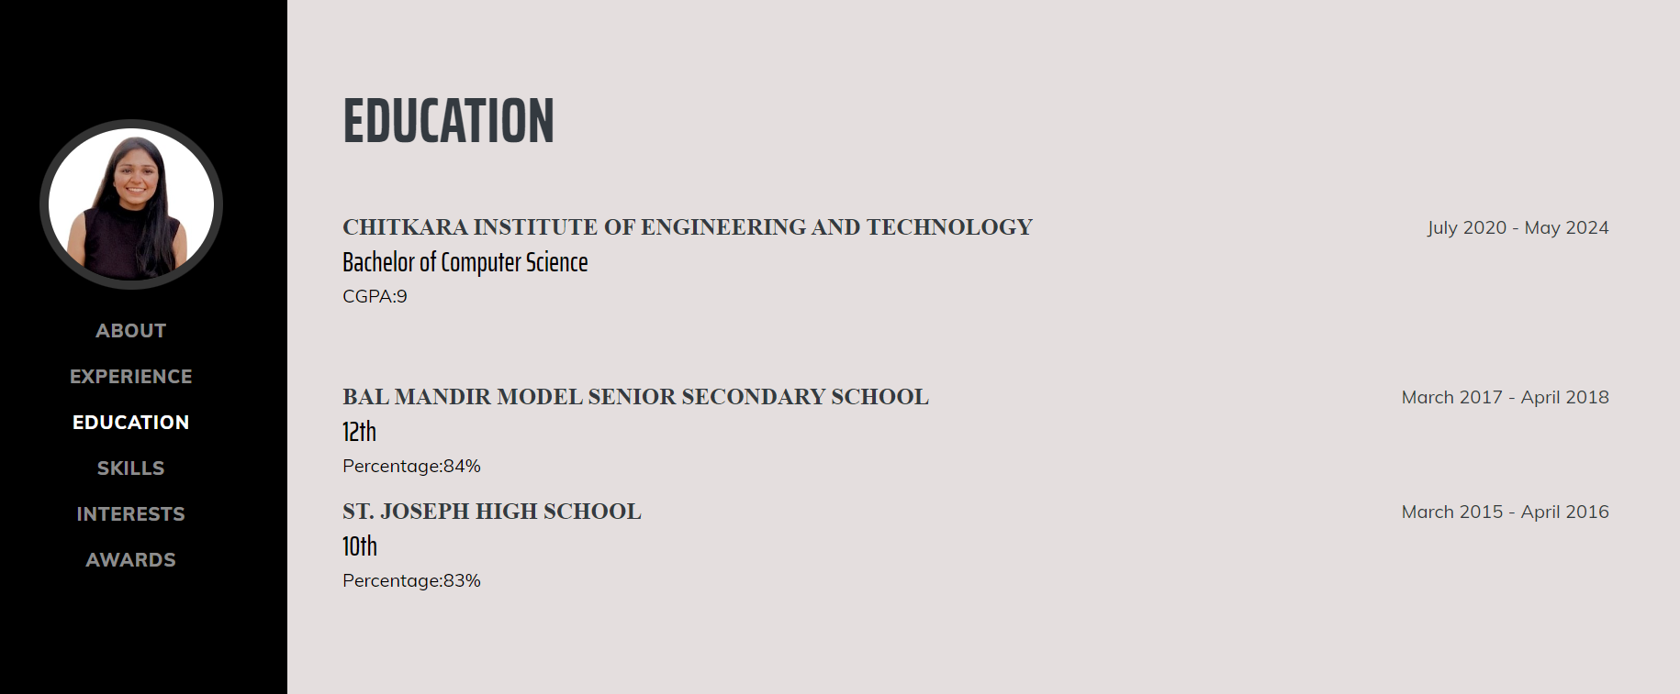

* This page elaborates my academic details required like higher education, secondary education and graduation.
* It is divided into two divs i.e. course name and year of completing.
* Class flex-column and justify-content-between is used to divide course name and year into two columns.
* Class flex-shrink-0 aligns the year and date in one row.

###### **SKILLS**

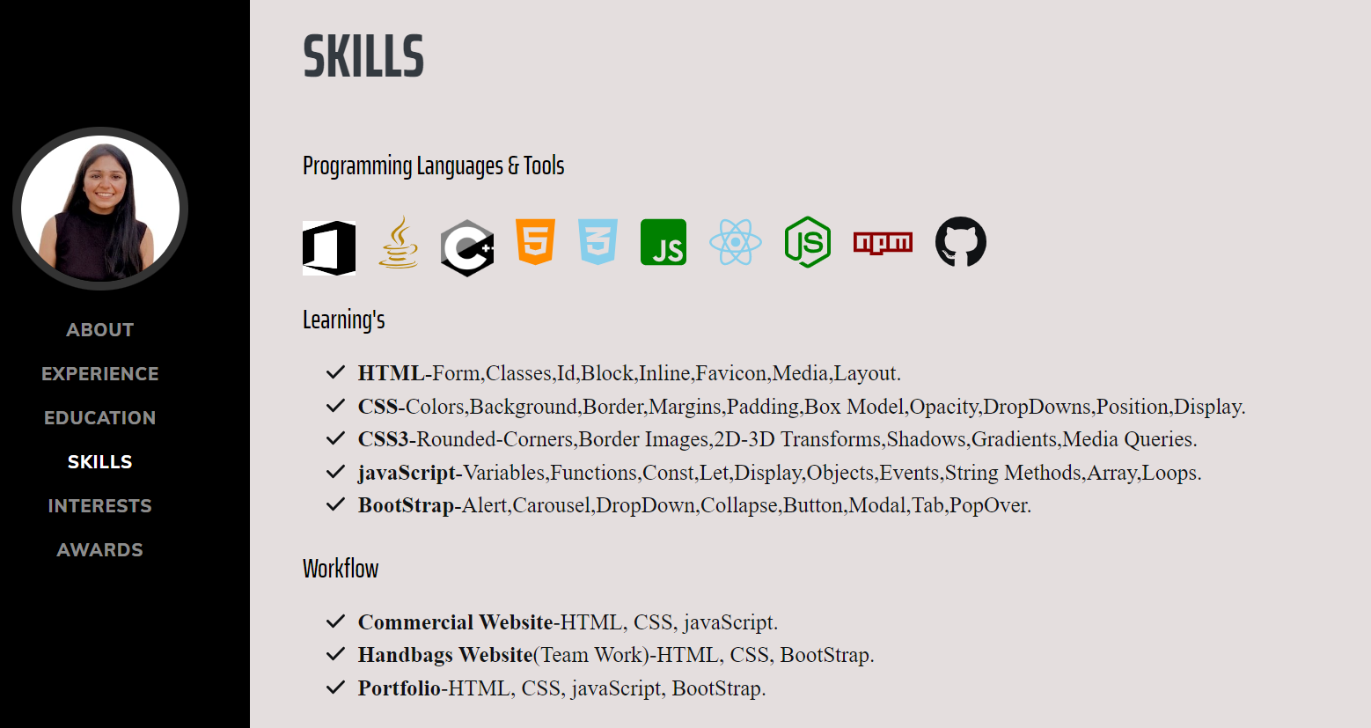

* This pages elaborates about programming skills I have learned so far and the workflow i.e. implementation of projects.
* Font awesome icons like MS Office, JAVA, C++, HTML, CSS ,CSS3 ,framework BOOTSTRAP , library JAVASCRIPT , Node JS, React, NPM, GITHUB are used.
* Different topics which I learned are stated under Learning section.
* Workflow represents the best project I made after learning this programming languages.
* Class line-inline-item is used to align all the icons in one row.
* Font awesome icon fas fa-check is used as tick mark for numbering the rows.

###### **INTERESTS**

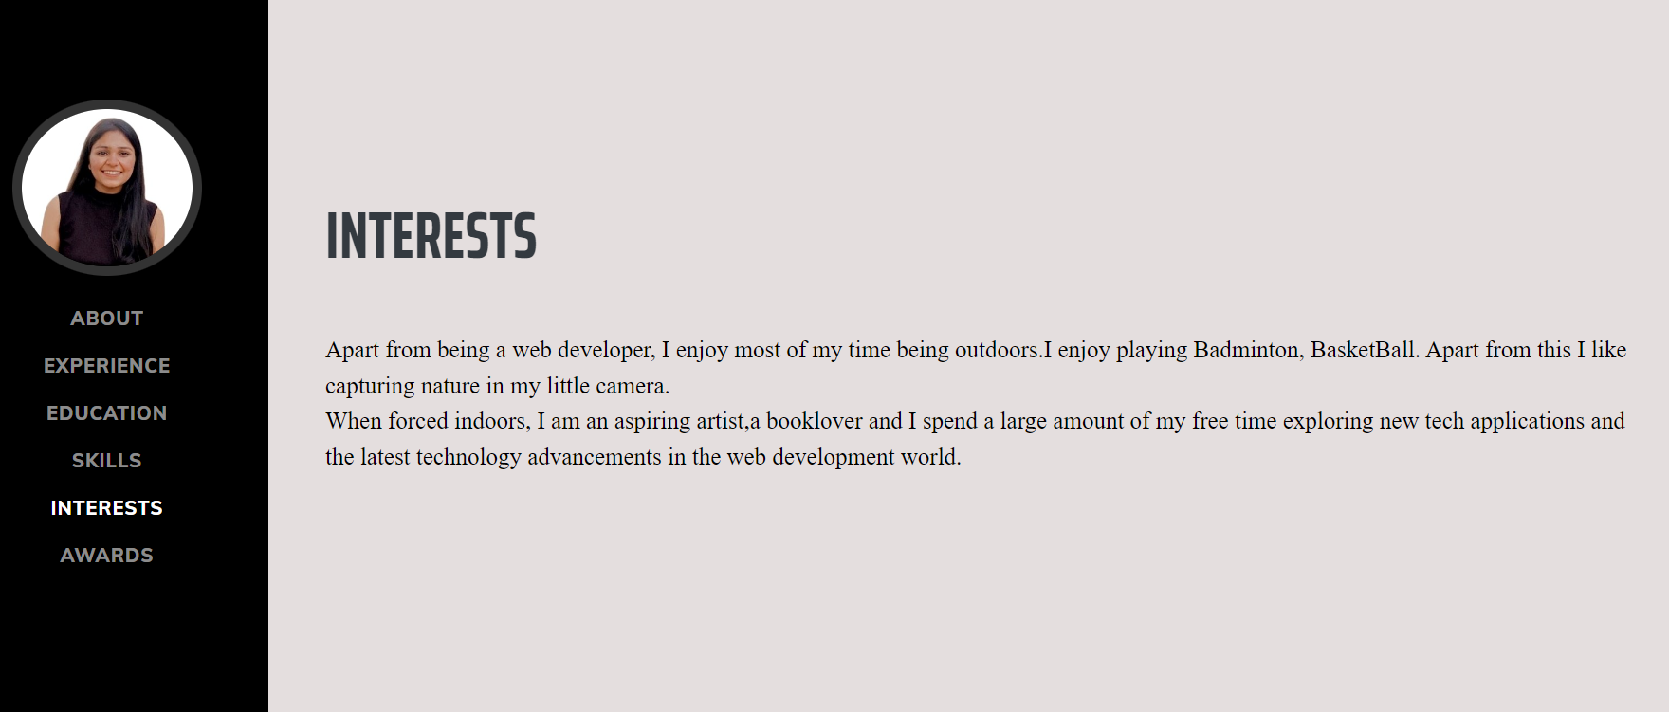

* This page elaborates my interests apart from programming.
* Outdoor games I am interested in and if forced indoors my inner artist comes out. Sometimes I am a book-reader also.
* Most of the time I spend exploring new technologies, reading about them and more.
* Margin bottom is used for the gap between text and title name.

###### **AWARDS**

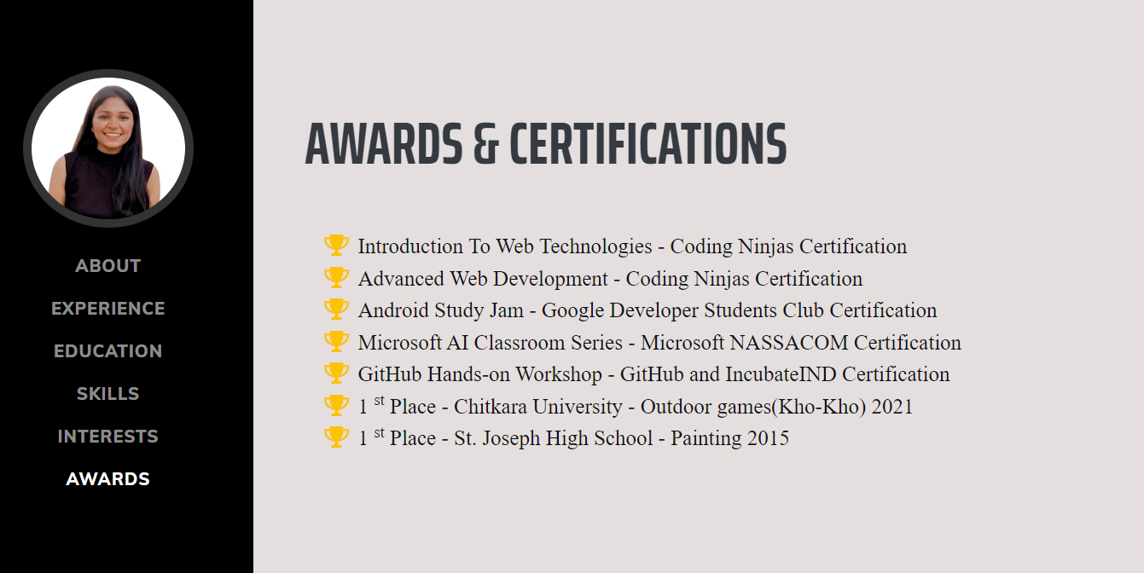

* This page elaborates my achievements in professional and in outdoor activities.
* Certificates like attending AI workshop by Microsoft, Android workshop by google student club or learning new programming language from coding ninja.
* Font awesome icons are used for trophy icon displayed in front of achievements i.e. fas fa-trophy text-warning.
* Class text-warning displays yellow color which inbuilt class in bootstrap5.

end

**learning**– HTML, CSS,CSS3,BOOTSTRAP, JAVASCRIPT